CompTia A+
A+ - Peripherals and Power Supply
Assignment-1
Day 1: Overview of Peripherals Theory (1 hour): Functions of printers, scanners, webcams, and their connection interfaces.
QUE-01 Create a table listing 3 types of printers, 2 types of scanners, and 2 types of webcams, and for each, write one real-life use case (for example: 'Inkjet printer – printing college assignments').
ANS
Category | Type | Real-Life Use Case
Printer | Inkjet Printer | Printing college assignments and colourful documents
Printer | Laser Printer | Printing large numbers of office documents quickly
Printer | 3D Printer | Creating prototypes or small 3D models
Scanner | Flatbed Scanner | Scanning certificates and important documents
Scanner | Sheet-fed Scanner | Scanning multiple pages of office paperwork
Webcam | Built-in Webcam | Attending online classes or video calls on a laptop
Webcam | External USB Webcam | Video conferencing on a desktop computer

QUE-02 Draw a labelled diagram showing how a typical home printer connects to a laptop or PC, including the connection interface used (USB, Wi-Fi, or Bluetooth).
ANS
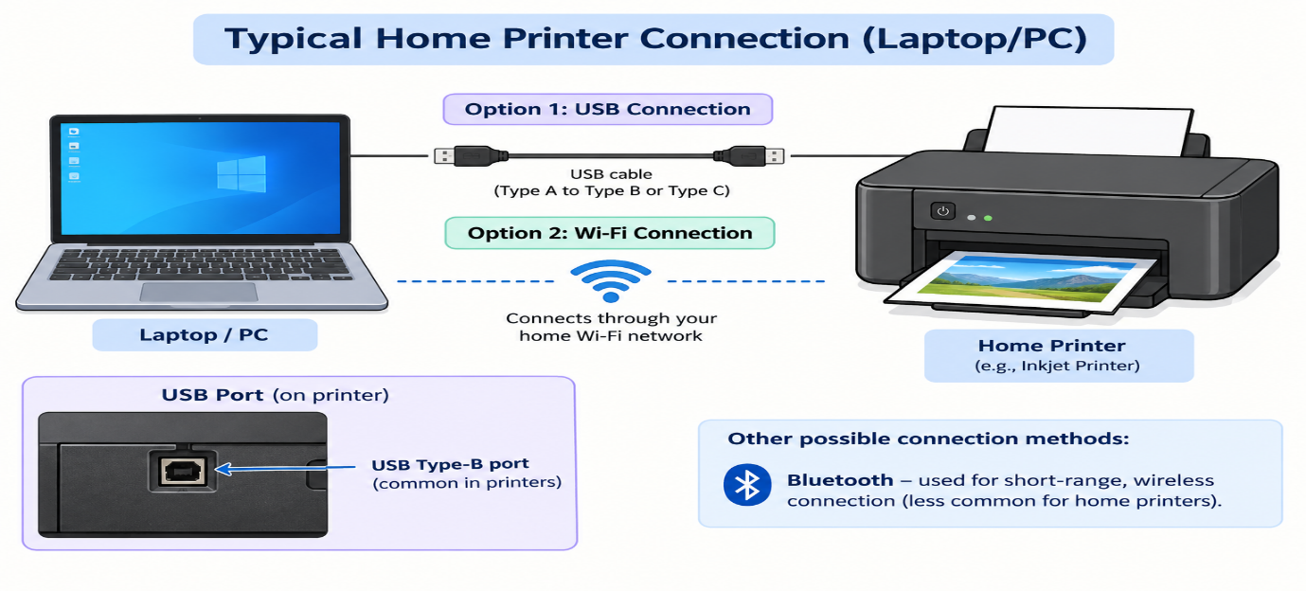

QUE-03
List three different connection interfaces (such as USB, Wi-Fi, Bluetooth) used by peripherals like printers, scanners, and webcams, and for each, name one advantage and one disadvantage. <br><br><em><strong>Hint:</strong> Think about speed, convenience, and compatibility. </em>
ANS
Connection Interface | Used By | Advantage | Disadvantage
USB | Printer, Scanner, Webcam | Fast data transfer and reliable connection | Requires a physical cable
Wi-Fi | Printer, Scanner | Wireless and convenient; multiple devices can connect | Requires a Wi-Fi network
Bluetooth | Webcam, Printer | Cable-free and easy to connect over short distances | Limited range and slower than USB

QUE-04
Pick any one device you use at home or college (printer, scanner, or webcam). Write step-by-step instructions for how you would connect it to your computer, including what cable or wireless method you would use and any setup steps required.
ANS
Device: Printer
Steps to connect a printer to a computer using USB:
- Switch on the printer and place it near the computer.
- Connect the USB cable from the printer’s USB port to the computer’s USB port.
- Turn on the printer and wait for the computer to detect it.
- If required, install the printer driver/software provided by the manufacturer.
- Open Settings → Bluetooth & devices → Printers & scanners on Windows.
- Select Add device and choose the connected printer.
- Set the printer as the default printer if needed.
- Print a test page to check whether the connection is working properly.
Connection method used: USB cable
Advantage: Fast and reliable connection.

